ECE 322L - Lab 5

March 5, 2013

Greg Iven

Mario Chaves

Table of Contents

Abstract 3

Procedure 3

Hand Calculations 4

PSPICE 6

PSPICE Code 6

PSPICE Simulation Output 6

Captured Results 8

Conclusion 9

List of Figures

Figure 1 – Given common collector amplifier 3

Figure 2 – Given common collector amplifier 3

Figure 3 – NI Three wire Current-Voltage Analyzer 10

Figure 4 – input frequency 10

Figure 5 – Source voltages 11

Figure 6 – Oscilloscope capture of Vre 11

Figure 7 – Oscilloscope capture of and input of 10mV @ 1KHz 12

# **Abstract**

This lab will calculate, simulate and build a common-collector and common-emitter amplifier.

# **Procedure**

This lab consists of two parts

Part 1 using the given circuit and its parameters we are to use the NI Three-wire analyzer to get beta from our used BJT transistor and calculate Re, Vce, and the Gain of the circuit. Once we solved for these values we were to simulate and build the circuit.



Figure 1 – Given common collector amplifier

Part 2 using the given circuit and its parameters we are to use the NI Three-wire analyzer to get beta from our used BJT transistor and calculate Re, Rc, Vce, and the Gain of the circuit. Once we solved for these values we were to simulate and build the circuit.

## 

Figure 2 – Given common collector amplifier

# Hand Calculations

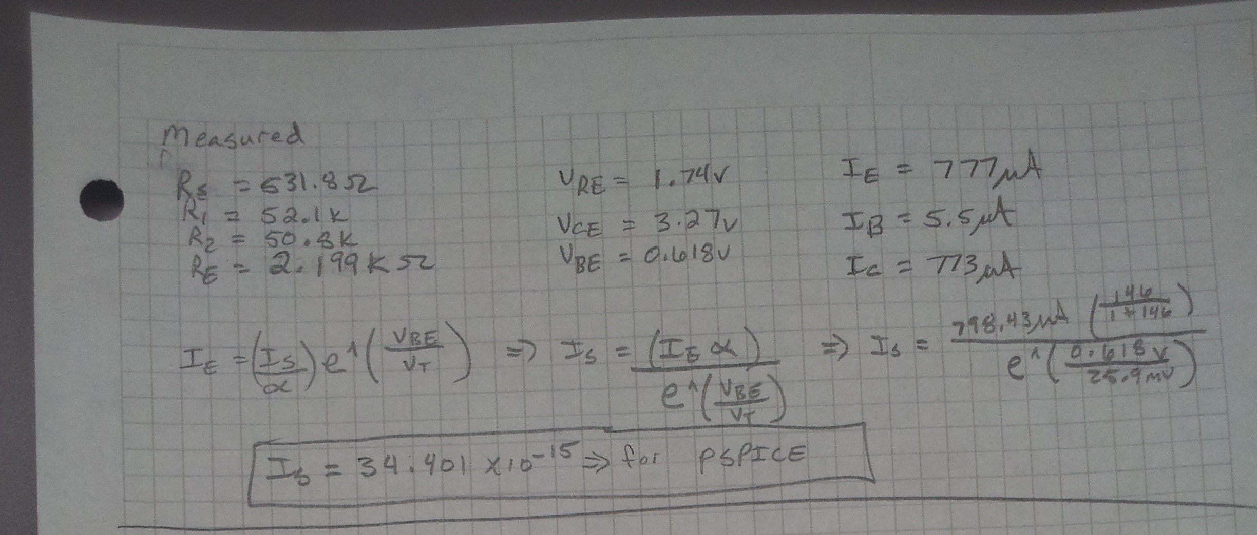

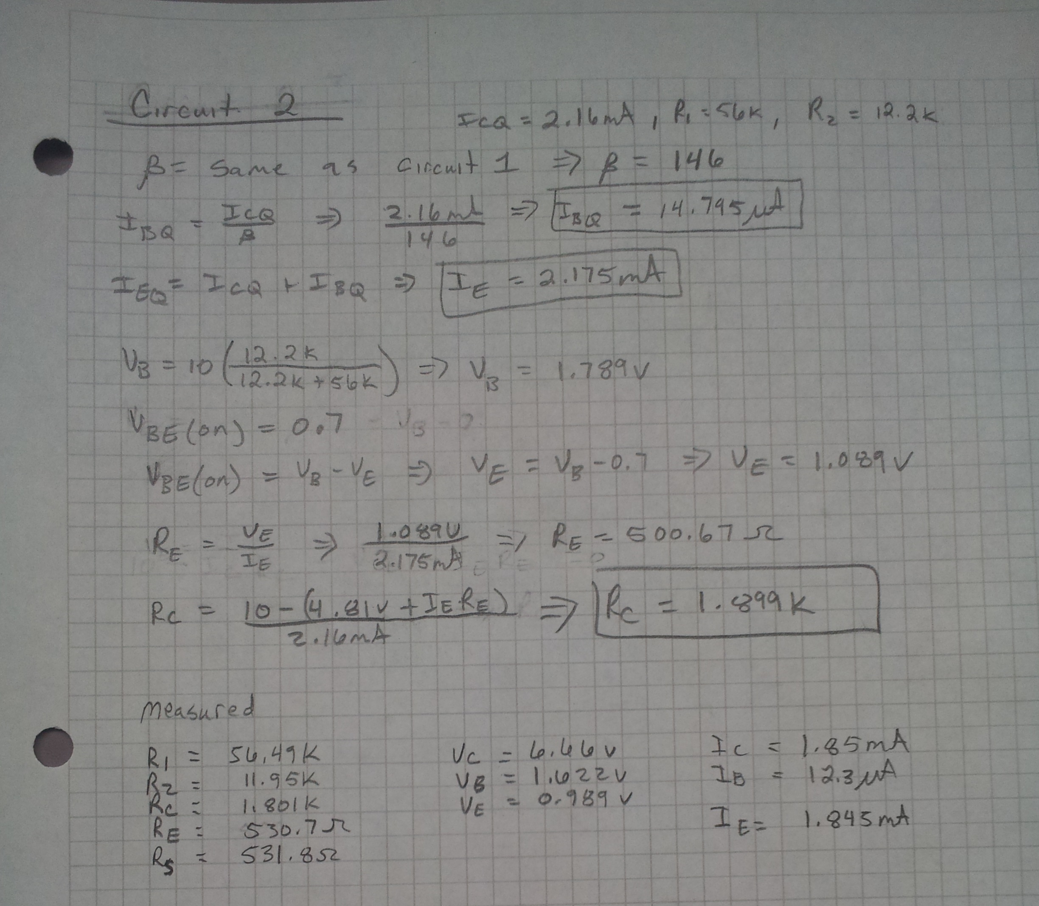

# PSPICE

## PSPICE Code for common collector

## **** CIRCUIT DESCRIPTION

## ******************************************************************************

## Vcc 1 0 DC 5

## Vs 5 0 AC 0.01 0

## C1 4 2 0.33uF

## R1 1 2 52.1k

## R2 2 0 50.8k

## RE 3 0 2.199K

## RS 5 4 531.8

## *Qxxx C B E NPN

## Q1 1 2 3 NPN

## .MODEL NPN NPN(BF=146 IS=34.401E-15)

## .OP

## **** 03/05/13 16:56:37 *********** Evaluation PSpice (Nov 1999) **************

## *ECE322L Lab 5 Circuit 1

## **** BJT MODEL PARAMETERS

## ******************************************************************************

## NPN

## NPN

## IS 34.401000E-15

## BF 146

## NF 1

## BR 1

## NR 1

## CN 2.42

## D .87

## **** 03/05/13 16:56:37 *********** Evaluation PSpice (Nov 1999) **************

## *ECE322L Lab 5 Circuit 1

## **** SMALL SIGNAL BIAS SOLUTION TEMPERATURE = 27.000 DEG C

## NODE VOLTAGE NODE VOLTAGE NODE VOLTAGE NODE VOLTAGE

## ( 1) 5.0000 ( 2) 2.3319 ( 3) 1.7154 ( 4) 0.0000 ( 5) 0.0000

## VOLTAGE SOURCE CURRENTS

## NAME CURRENT

## Vcc -8.260E-04

## Vs 0.000E+00

## TOTAL POWER DISSIPATION 4.13E-03 WATTS

## **** 03/05/13 16:56:37 *********** Evaluation PSpice (Nov 1999) **************

## *ECE322L Lab 5 Circuit 1

## **** OPERATING POINT INFORMATION TEMPERATURE = 27.000 DEG C

## ******************************************************************************

## **** BIPOLAR JUNCTION TRANSISTORS

## NAME Q1

## MODEL NPN

## IB 5.31E-06

## IC 7.75E-04

## VBE 6.17E-01

## VBC -2.67E+00

## VCE 3.28E+00

## BETADC 1.46E+02

## GM 3.00E-02

## RPI 4.87E+03

## RX 0.00E+00

## RO 1.00E+12

## CBE 0.00E+00

## CBC 0.00E+00

## CJS 0.00E+00

## BETAAC 1.46E+02

## CBX/CBX2 0.00E+00

## FT/FT2 4.77E+17

## PSPICE Code for common emitter

**** CIRCUIT DESCRIPTION

******************************************************************************

Vcc 1 0 DC 10

Vs 5 0 AC 0.01 0

C1 4 2 0.33uF

R1 1 2 56.49k

R2 2 0 11.95k

RC 1 6 1.801k

RE 3 0 530.7

RS 5 4 531.8

*Qxxx C B E NPN

Q1 6 2 3 NPN

.MODEL NPN NPN(BF=146 IS=52.1513E-15)

.OP

**** 03/05/13 16:54:50 *********** Evaluation PSpice (Nov 1999) **************

*ECE322L Lab 5 Circuit 2

**** BJT MODEL PARAMETERS

******************************************************************************

NPN

NPN

IS 52.151300E-15

BF 146

NF 1

BR 1

NR 1

CN 2.42

D .87

**** 03/05/13 16:54:50 *********** Evaluation PSpice (Nov 1999) **************

*ECE322L Lab 5 Circuit 2

**** SMALL SIGNAL BIAS SOLUTION TEMPERATURE = 27.000 DEG C

******************************************************************************

NODE VOLTAGE NODE VOLTAGE NODE VOLTAGE NODE VOLTAGE

( 1) 10.0000 ( 2) 1.6206 ( 3) .9922 ( 4) 0.0000 ( 5) 0.0000 ( 6) 6.6557

VOLTAGE SOURCE CURRENTS

NAME CURRENT

Vcc -2.005E-03

Vs 0.000E+00

TOTAL POWER DISSIPATION 2.01E-02 WATTS

**** 03/05/13 16:54:50 *********** Evaluation PSpice (Nov 1999) **************

*ECE322L Lab 5 Circuit 2

**** OPERATING POINT INFORMATION TEMPERATURE = 27.000 DEG C

******************************************************************************

**** BIPOLAR JUNCTION TRANSISTORS

NAME Q1

MODEL NPN

IB 1.27E-05

IC 1.86E-03

VBE 6.28E-01

VBC -5.04E+00

VCE 5.66E+00

BETADC 1.46E+02

GM 7.18E-02

RPI 2.03E+03

RX 0.00E+00

RO 1.00E+12

CBE 0.00E+00

CBC 0.00E+00

CJS 0.00E+00

BETAAC 1.46E+02

CBX/CBX2 0.00E+00

FT/FT2 1.14E+18

# Captured Results

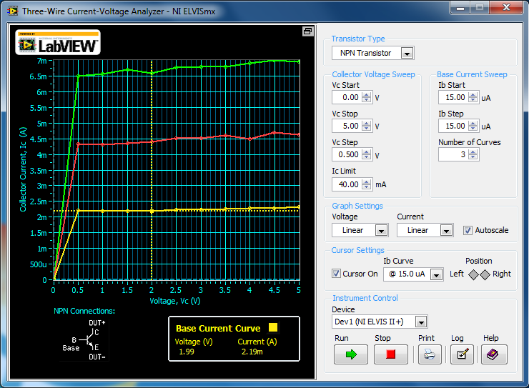

Figure 3 – NI Three wire Current-Voltage Analyzer

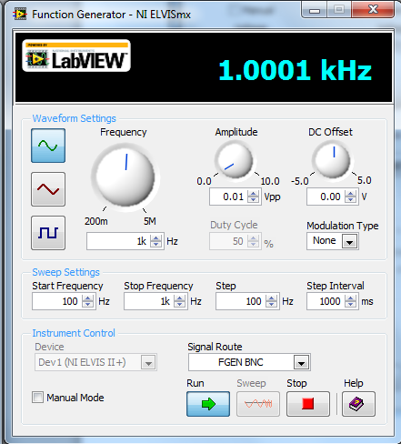

Figure 4 – input frequency

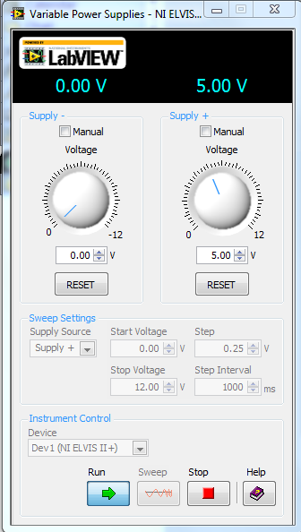

Figure 5 – Source voltages

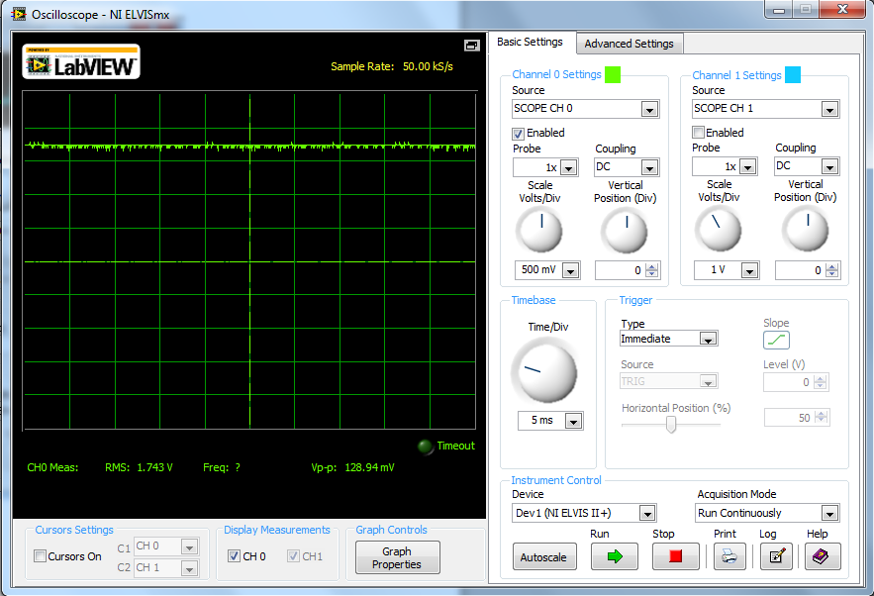

Figure 6 – Oscilloscope capture of Vre

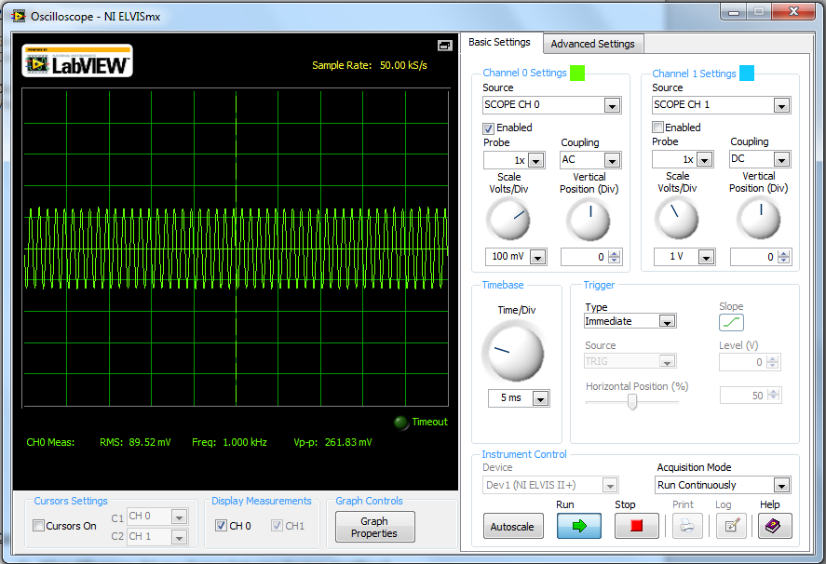

Figure 7 – Oscilloscope capture of and input of 10mV @ 1KHz

Conclusion  
By performing this experiment we gained more experience with PSPICE by implementing a more involved circuit which will prove to be very helpful in the future. Through our hand calculations we were able to learn more about the electrical characteristics of transistors and calculate a more complex circuit including its gain. Our calculations seemed to match to output of our circuits. These amplifier circuits can be applied almost everywhere from audio amplifiers to sensor detection circuits. This lab gave us some grief using the ELVIS because of the intermittent connections and the extra internal impedances/capacitances within but, other than that this lab was a good lesson learned.